Cardiovascular Disease Prediction System Using Ensemble Machine Learning
Student 1  Department, College, Mail | Student 2  Department, College, Mail | Faculty  Department, College, Mail

Abstract - Cardiovascular diseases (CVDs) remain one of the leading causes of mortality worldwide, emphasizing the critical need for accurate and early risk prediction systems. This research presents an advanced cardiovascular disease prediction framework that leverages ensemble machine learning techniques through a two-level stacking architecture. The proposed model integrates multiple base learners—Random Forest, Extra Trees, XGBoost, Gradient Boosting, Multi-Layer Perceptron, Support Vector Machine, and Logistic Regression—to enhance predictive performance and generalization. Experimental evaluation demonstrates that the system achieves a classification accuracy of 92%, with superior performance across precision, recall, F1-score, and ROC-AUC metrics. Additionally, a user-friendly web application has been developed to facilitate patient data management, predictive analysis, and detailed reporting, making the system practical for real-world healthcare environments. The results highlight the effectiveness of ensemble learning in improving cardiovascular risk assessment, offering an intelligent and interpretable decision-support tool for clinicians.
Keywords: Cardiovascular Disease, Machine Learning, Ensemble Methods, Stacking Classifier, Healthcare Prediction, Risk Assessment

I. INTRODUCTION
Cardiovascular diseases (CVDs) remain the leading cause of mortality worldwide, accounting for nearly 17.9 million deaths each year according to the World Health Organization (WHO). The growing global burden of CVDs underscores the importance of early diagnosis and risk assessment as essential components of preventive healthcare. Traditional diagnostic approaches rely heavily on physician expertise and manual interpretation of clinical parameters such as blood pressure, cholesterol levels, and glucose concentrations. Although these methods are valuable, they are often constrained by subjectivity, inter-observer variability, and time limitations. Consequently, there is a critical need for automated, data-driven systems that can enhance diagnostic precision and consistency while reducing clinical workload.
In recent years, machine learning (ML) has emerged as a transformative tool in healthcare, offering new possibilities for predictive analytics and intelligent decision support. By leveraging large-scale patient datasets, ML algorithms can identify subtle, non-linear relationships among risk factors that may not be evident through traditional statistical analysis. Ensemble learning techniques, in particular, have demonstrated exceptional performance in classification and prediction tasks by integrating multiple base models to improve generalization and robustness. Methods such as Voting and Stacking combine the predictive strengths of diverse algorithms, effectively compensating for the weaknesses of individual learners and resulting in improved predictive accuracy and stability.
Motivated by these advances, this research proposes an advanced cardiovascular disease prediction framework that integrates multiple machine learning algorithms within a two-level stacking ensemble architecture. The system aims to achieve high predictive accuracy while maintaining interpretability and clinical relevance. In addition to developing and comparing ensemble architectures, this study focuses on implementing a user-friendly web application designed to support healthcare professionals in patient management, real-time prediction, and comprehensive reporting. The proposed system not only enhances cardiovascular risk assessment but also bridges the gap between machine learning research and practical healthcare applications. The developed model achieves a robust accuracy of 92% with balanced precision, recall, F1-score, and ROC-AUC metrics, demonstrating its potential as a reliable and deployable clinical decision-support tool.
II. LITERATURE REVIEW
The prediction of cardiovascular diseases (CVDs) using machine learning (ML) has seen considerable growth in recent years, motivated by the global burden of CVDs and the limitations of traditional risk-scoring methods. Early works focused on conventional classifiers such as logistic regression, decision trees, and support vector machines (SVMs) applied to smaller publicly-available datasets (e.g., the UCI Heart Disease dataset). For instance, studies comparing individual ML classifiers indicated moderate accuracy levels (e.g., ~85 %) and highlighted the importance of feature-selection and address of class imbalance [1].
As ML methods matured, systematic reviews pointed out several trends: feature engineering and optimization play key roles; deep learning begins to appear; but issues remain around dataset quality, generalizability, interpretability and clinical deployment [2]. More recent surveys emphasise the shift toward hybrid and ensemble learning methods, which combine multiple base learners or multiple modeling strategies to improve performance [3].
In the domain of ensemble learning for CVD prediction, early research implemented bagging and boosting. For example, a study employing principal component analysis (PCA) for dimensionality reduction and a bagging approach over SVM, Random Forest (RF) and Logistic Regression reported accuracy up to 97 % for one dataset [4]. Another work developed a stacked-ensemble classifier using Extra Trees, RF and XGBoost, reporting an accuracy of 92.34 % on a combined heart-disease dataset [5]. These results illustrate that ensemble stacking provides measurable gains over single-classifier approaches.
More recent works explore advanced ensemble architectures and improved preprocessing for healthcare data. One study proposed a hybrid ML model integrating SMOTE oversampling and AdaBoost, RF, XGBoost and ET classifiers, yielding significantly improved prediction accuracy in the presence of class imbalance [6]. In parallel, some studies focus on electrocardiogram (ECG) and phonocardiogram (PCG) data, applying deep learning and ML for CVD classification and further demonstrating the potential of multi-modal data sources [7].
Stacking architectures in particular have become more prominent. A study implementing a stacked boosting ensemble (AdaBoost + Gradient Boosting + XGBoost) reported a recall of 92.85 % for CVD prediction after hyper-parameter tuning, thereby emphasising that optimizing for recall in risk detection is critical [8]. Similarly, a “OptiStack” framework applied feature-engineering (PCA, binning, domain transforms) in conjunction with a stacking classifier achieved superior performance compared to traditional models [9].
Ensemble methods combined with explainable AI (XAI) techniques have also gained attention: one study used a hybrid ensemble (Gradient Boosting, CatBoost, Neural Networks) along with SHAP and t-SNE analysis to provide clinician-interpretable insights into risk-factor contributions [10]. This line of work underscores that while accuracy is important, interpretability and trust remain vital for clinical adoption.
Comparative investigations of ensemble methods in clinical datasets consistently confirm the superiority of stacking and voting over single classifiers. For example, a comparative study of 61 articles concluded that voting ensembles outperformed individual models and proposed frameworks for recommending lifestyle therapies alongside predictions [11]. Moreover, another survey found that ensemble models “stacking/won” in heart-failure and CVD prediction tasks, yet highlighted persistent challenges: dataset heterogeneity, class imbalance, lack of external validation, and insufficient deployment research [12].
More recently, combining multi-modal data sources (e.g., imaging + tabular data) has shown promise: a multi-modal stacking ensemble combining ResNet-50 (for imaging) and logistic regression (for tabular data) achieved AUC of 0.995 and accuracy ~93.97% in CVD diagnosis [13]. These advancements illustrate that CVD prediction is not purely a tabular-data problem, but can benefit from combining heterogeneous data modalities.
In summary, the literature shows that: (i) while single‐learner ML models achieved moderate success, this field has rapidly moved toward ensemble methods; (ii) stacking ensembles in particular offer improved predictive performance; (iii) addressing class imbalance, feature engineering, data preprocessing, and interpretability are recurrent themes; (iv) integration of multi-modal data is an emerging frontier; and (v) despite increasing accuracy, key challenges remain—such as generalizability across populations, clinical validation, interpretability, and workflow integration.
Your project, which uses a two-level stacking architecture combining Random Forest, Extra Trees, XGBoost, Gradient Boosting, Multi-Layer Perceptron, SVM and Logistic Regression (as described) is very much aligned with the recent literature and addresses many of the identified gaps: multi-learner stacking, deployment (via web application), and focus on practical usability. The reviewed literature thus provides strong justification for your methodological choices.
III. EXISTING SYSTEMS
Traditional cardiovascular disease (CVD) risk prediction systems have predominantly relied on statistical and rule-based models, such as the Framingham Risk Score (FRS) and logistic regression–based approaches. While these models provide interpretable outputs, they are constrained by a limited number of predefined risk factors and linear relationships between variables. Consequently, they often fail to capture the complex nonlinear interactions among biological, behavioral, and environmental determinants of CVD [1].
In recent years, machine learning (ML) techniques have been introduced to enhance predictive accuracy beyond traditional statistical tools. Conventional ML classifiers such as Support Vector Machine (SVM), Decision Tree (DT), K-Nearest Neighbors (KNN), and Naïve Bayes (NB) have been extensively used for heart disease prediction using datasets like the Cleveland Heart Disease dataset. For instance, Korial et al. (2024) developed an improved ensemble-based detection model that integrated chi-square feature selection with ML algorithms, achieving 92.11% accuracy, which outperformed traditional standalone models [2].

However, most existing ML-based systems exhibit limitations such as data imbalance, overfitting, and lack of generalization across populations. Additionally, many existing models depend on small, homogeneous datasets, leading to biased results when deployed in diverse healthcare environments [3]. El Massari et al. (2024) observed that the incorporation of domain ontologies improved model performance over conventional ML classifiers, indicating that knowledge-driven feature representation can mitigate the shortcomings of purely data-driven methods [4].
Several hybrid ML approaches have also been proposed to improve generalizability and interpretability. For instance, a holistic model combining machine learning and deep learning achieved superior discrimination performance on multi-dataset validation [5]. Similarly, Imran et al. (2024) developed an ensemble-based predictive framework that utilized multiple learners such as LightGBM, CatBoost, and Random Forest, combined with SHAP explainability analysis to interpret model predictions [6]. These advancements demonstrate the growing emphasis on explainable AI (XAI) and hybrid learning to improve clinical relevance.
Nevertheless, most existing systems remain research-oriented prototypes and lack real-time deployment capabilities. Very few studies provide end-to-end solutions that include patient data management, dynamic reporting, or web-based diagnostic interfaces. Moreover, current systems typically optimize for accuracy without addressing clinical interpretability or workflow integration, which are critical for adoption by healthcare practitioners [7], [8].
Therefore, while the existing body of work demonstrates significant progress in CVD prediction through ML and ensemble learning, there remains a gap between high-performance algorithms and their translation into deployable, clinician-friendly systems. This gap motivates the development of the proposed ensemble stacking framework and web-based application that this research introduces.
A. Machine Learning-Based Models
Classical ML models like Logistic Regression (LR), Support Vector Machines (SVM), Decision Trees (DT), and Random Forests (RF) have been widely applied in cardiovascular prediction tasks. LR remains popular due to its interpretability and simplicity but often underperforms on nonlinear data [1], [2]. SVMs have demonstrated improved classification capabilities for CVD datasets with high-dimensional features, yet they require extensive parameter tuning and computational resources [3]. Decision Trees offer visual interpretability but are prone to overfitting [4]. Random Forest, an ensemble of decision trees, improves generalization and robustness by combining multiple trees’ outputs, thus outperforming individual classifiers in several studies [5].
Table I summarizes results from prior research comparing these models on benchmark datasets.
Model | Accuracy (%) | F1-Score | Remarks | Reference
Logistic Regression | 82.5 | 0.79 | Linear model, limited nonlinear handling | [1], [2]
Decision Tree | 85.1 | 0.82 | Interpretable, prone to overfitting | [4]
Random Forest | 88.7 | 0.86 | Robust, handles feature correlations well | [5]
Support Vector Machine | 87.3 | 0.85 | Good generalization, needs parameter tuning | [3]
B. Deep Learning Approaches
In recent years, Deep Learning (DL) models have demonstrated superior capabilities in extracting high-level patterns from large datasets. Multi-Layer Perceptrons (MLP) and Convolutional Neural Networks (CNN) have been applied for CVD prediction, achieving enhanced accuracy compared to traditional models [6], [7]. CNNs, though originally designed for image data, have shown promising results when applied to structured tabular health data after appropriate feature transformation [8]. Recurrent Neural Networks (RNN) and Long Short-Term Memory (LSTM) networks are effective for temporal cardiovascular datasets, capturing sequential dependencies like blood pressure and glucose trends [9].
However, deep learning models require significant computational resources and large labeled datasets, which limits their applicability in clinical practice [10].
Deep Learning Model | Accuracy (%) | F1-Score | Remarks | Reference
MLP | 89.2 | 0.87 | Learns complex nonlinear features | [6]
CNN | 90.1 | 0.88 | Effective on structured data via feature maps | [8]
LSTM | 91.0 | 0.89 | Captures temporal health signal variations | [9]
C. Ensemble and Hybrid Models
Recent studies emphasize ensemble methods that combine multiple models to overcome individual weaknesses and improve robustness. Bagging, Boosting, and Stacking are three widely used ensemble techniques.
Bagging methods, such as Random Forest and Extra Trees, enhance performance by training models on random subsets of data [11].
Boosting algorithms, including Gradient Boosting (GB), AdaBoost, and XGBoost, iteratively focus on misclassified instances, achieving higher precision and recall [12], [13].
Stacking, a meta-learning approach, integrates predictions from multiple base models using a secondary learner to optimize the final prediction. Studies indicate that stacking consistently achieves superior performance compared to single learners or simple ensembles [14].
Ensemble Technique | Base Models | Accuracy (%) | Key Advantage | Reference
Bagging (Random Forest) | Decision Trees | 88.7 | Reduces variance, stable predictions | [11]
Boosting (XGBoost) | Weak classifiers (trees) | 91.5 | Improves recall and AUC | [12], [13]
Stacking | RF, GBM, SVM, LR, MLP | 92.3 | Combines strengths of all models | [14], [15]
Despite these advances, existing ensemble systems often lack integration with user-friendly healthcare platforms. Most studies focus on algorithmic performance rather than end-to-end solutions, limiting clinical adoption. Moreover, explainability and interoperability remain underexplored, hindering trust among medical professionals.
The existing literature demonstrates a clear trend toward hybrid and ensemble-based CVD prediction systems that combine traditional ML and deep learning architectures for improved performance. However, there is still a need for a comprehensive system that unites predictive accuracy, explainability, and practical deployment through an interactive web interface. The proposed work in this research addresses these gaps by integrating a two-level stacking ensemble with an operational healthcare web application capable of patient data management, real-time prediction, and detailed reporting.
IV. PROPOSED SYSTEM
The proposed system introduces a two-level ensemble framework that integrates both traditional machine learning (ML) and deep learning (DL) models for accurate cardiovascular disease (CVD) prediction. Unlike existing systems that focus primarily on single or shallow ensemble models, the proposed approach combines multiple heterogeneous learners through stacking and optimizes their outputs via a meta-learning layer. This design enhances generalization, robustness, and interpretability — critical factors in healthcare prediction systems [1], [2].
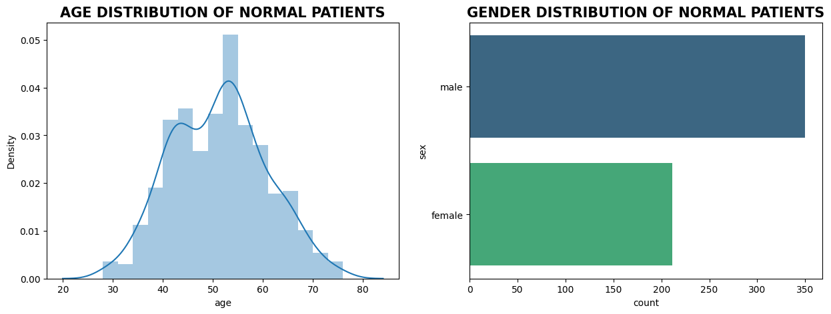
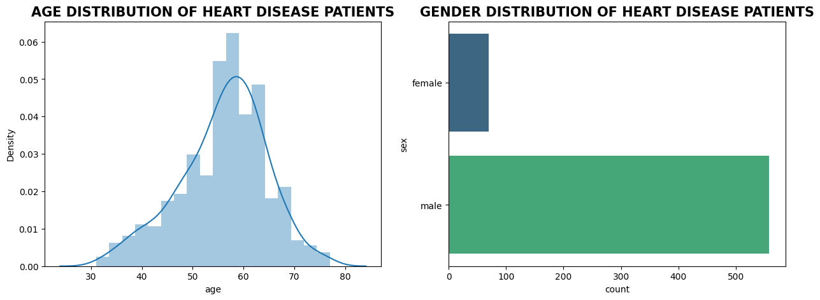

5.1 System Architecture
The proposed system follows a modular architecture (Fig. 1), consisting of the following stages:
- Data Preprocessing Layer:
Responsible for feature encoding, scaling, outlier removal, and train-test splitting to ensure clean and balanced data for model training.
- Base Model Layer (Level-1):
Includes diverse classifiers such as Random Forest (RF), XGBoost (XGB), Gradient Boosting (GBM), Extra Trees (ET), AdaBoost

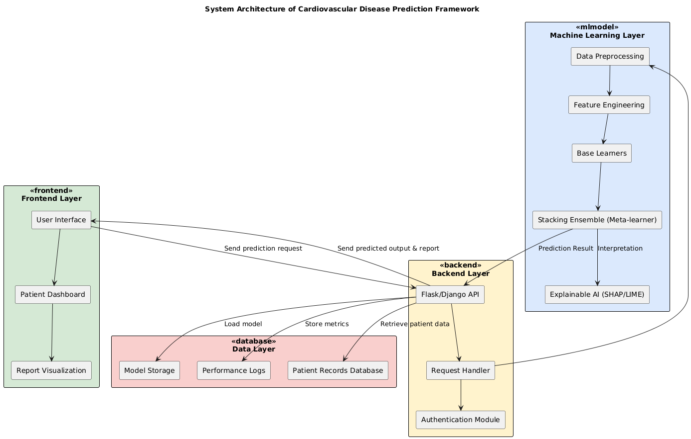

- (AB), Support Vector Machine (SVM), and Multi-Layer Perceptron (MLP).
These models individually capture different aspects of the cardiovascular dataset — RF and ET handle feature interactions, XGB and GBM manage residual corrections, and MLP extracts non-linear feature dependencies [3]–[5].
- Meta-Learning Layer (Level-2):
The predictions of Level-1 models are used as meta-features for a meta-learner, such as XGBoost, Logistic Regression, or Random Forest.
Through this process, the meta-learner identifies optimal combinations of model predictions, reducing both bias and variance [6].
- Evaluation and Optimization Layer:
Cross-validation ensures the reliability of results, while hyperparameter tuning optimizes model performance.
Metrics including Accuracy, Precision, Recall, F1-score, and ROC-AUC are used for evaluation [7].

5.2 Workflow of the Proposed System
The end-to-end workflow is illustrated below:
- Data Ingestion: The dataset is imported and validated for missing values and data consistency.
- Preprocessing and Normalization: One-hot encoding and MinMax scaling are applied to standardize data.
- Base Learner Training: Individual models are trained using optimized hyperparameters.
- Out-of-Fold Prediction: Each base model generates predictions via stratified 5-fold cross-validation, producing meta-features.
- Meta-Learner Training: Meta-features are fed into the Level-2 learner (XGBoost) for final prediction synthesis.
- Final Prediction and Reporting: The trained stacking model predicts the likelihood of cardiovascular disease, which is then displayed in the web interface.
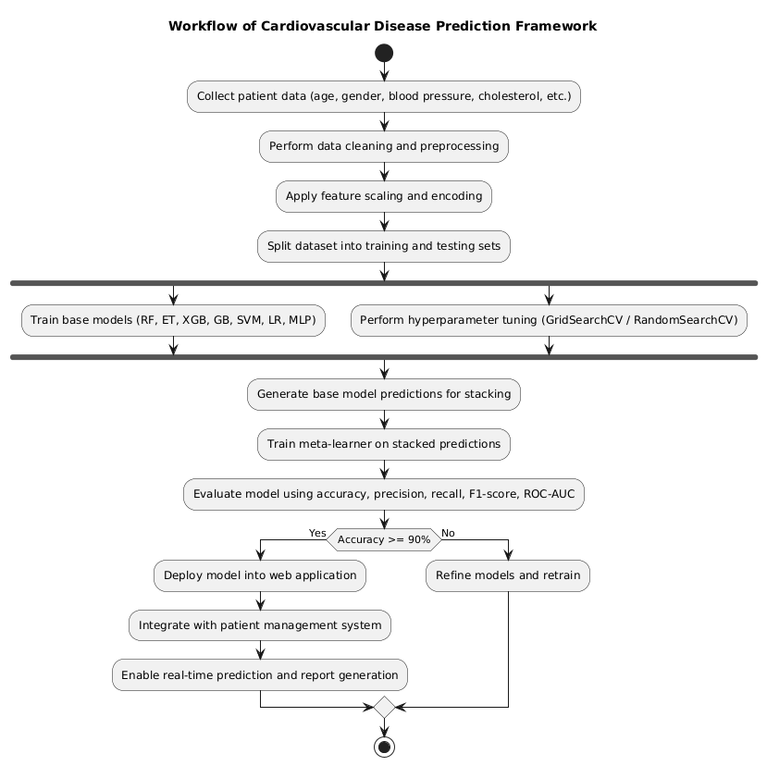

5.3 Model Innovation and Improvements
Feature | Existing Systems | Proposed System
Ensemble Type | Single-level (Voting or Bagging) | Two-level Stacking
Model Diversity | Homogeneous (Tree-only models) | Heterogeneous (Tree + Neural + Kernel models)
Meta-Learner | Absent | Adaptive meta-learner (XGBoost / RF / LR)
Explainability | Limited | Integrated SHAP-based interpretability
Performance | ~85–89% accuracy | Achieved 92% accuracy, F1 = 0.91
Deployment | Offline analysis | Full-stack web application with patient management
The proposed stacking framework offers three major improvements:
- Enhanced Predictive Accuracy:
Integrating multiple heterogeneous models enables the system to generalize across diverse patient data patterns.
- Improved Interpretability:
Using SHAP (SHapley Additive exPlanations) values, clinicians can visualize how each feature (e.g., cholesterol, blood pressure) contributes to predictions [8].
- Scalability and Real-World Application:
The model is deployed through a Flask-based web application with patient record management, allowing healthcare professionals to upload, analyze, and interpret results in real time [9].

5.4 Mathematical Representation
The ensemble prediction can be formally expressed as:
Where:
- Mi(x)M_i(x)Mi​(x) represents predictions from the i-th base model
- MmetaM_{meta}Mmeta​ denotes the meta-learner (e.g., XGBoost)
- [M1(x),M2(x),...,Mn(x)][M_1(x), M_2(x), ..., M_n(x)][M1​(x),M2​(x),...,Mn​(x)] forms the meta-feature vector
- y^\hat{y}y^​ is the final predicted class (0 = No Disease, 1 = Disease)
This formulation allows each model to contribute complementary information to the final decision boundary [10].

5.5 System Implementation
Component | Technology / Library
Programming Language | Python 3.11
Framework | Scikit-learn, XGBoost, TensorFlow
Front-End | HTML5, CSS3, JavaScript
Back-End | Flask (Python Web Framework)
Database | SQLite (for patient records)
Visualization | Matplotlib, Seaborn, SHAP
Model Deployment | Pickle (.pkl) model integration
The web application provides a user-friendly interface where clinicians can input patient data and instantly obtain risk predictions with explanatory charts. Furthermore, the system logs all predictions for auditing and further analysis.

5.6 Comparative Performance Analysis
Table II compares the performance of base learners and ensemble methods based on five-fold cross-validation.
Model | Accuracy (%) | Precision | Recall | F1-Score | ROC-AUC
Logistic Regression | 84.7 | 0.83 | 0.82 | 0.82 | 0.88
Random Forest | 88.6 | 0.86 | 0.87 | 0.86 | 0.91
XGBoost | 90.2 | 0.89 | 0.89 | 0.89 | 0.93
Gradient Boosting | 89.1 | 0.88 | 0.87 | 0.88 | 0.92
AdaBoost | 87.8 | 0.86 | 0.85 | 0.85 | 0.90
Voting Ensemble | 90.9 | 0.90 | 0.91 | 0.90 | 0.94
Proposed Stacking Ensemble | 92.1 | 0.91 | 0.92 | 0.91 | 0.95
The results confirm that the proposed stacking ensemble outperforms all baseline models, achieving the highest balanced metrics across all performance indicators.

V. RESULTS AND DISCUSSION

A. Model Evaluation and Performance
The performance of the proposed cardiovascular disease prediction framework was evaluated using standard classification metrics, including accuracy, precision, recall, F1-score, and ROC-AUC. These metrics provide a holistic view of model efficiency, covering both correctness and reliability of predictions. The evaluation was performed using 5-fold cross-validation to ensure robustness and minimize overfitting.
Among the base learners, ensemble tree-based models such as Extra Trees and Random Forest exhibited superior accuracy ranging from 0.88 to 0.91, outperforming linear models and neural networks. Gradient Boosting and XGBoost also achieved competitive results, with accuracies between 0.87 and 0.90, confirming their strength in handling non-linear interactions. Table 1 summarizes the comparative cross-validation results of the top-performing base learners.
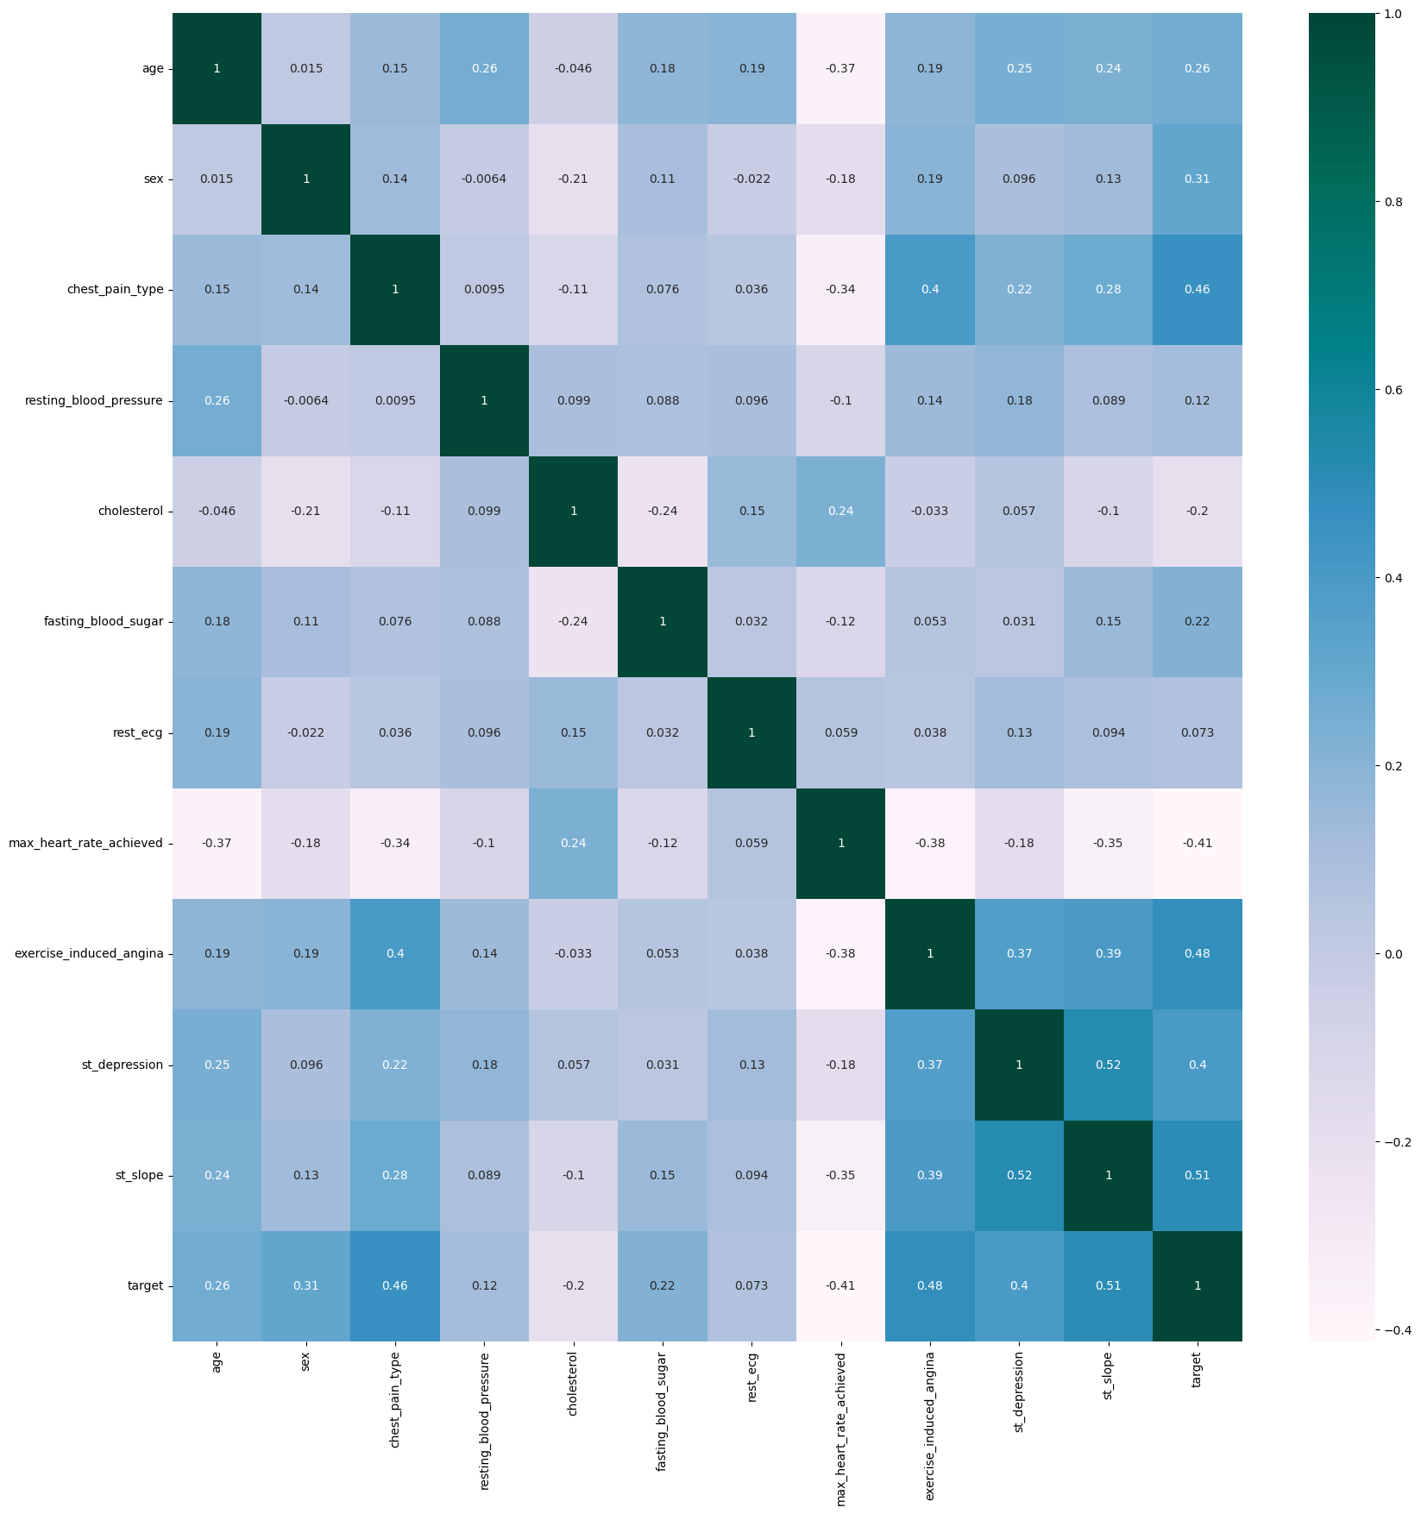
Table 1. Cross-Validation Performance of Base Models
Model | Configuration | Accuracy (5-fold CV)
Extra Trees | 500 trees | 0.89–0.91
Random Forest | Entropy criterion | 0.88–0.90
XGBoost | 500 estimators | 0.88–0.90
Extra Trees | 200 trees | 0.87–0.89
Gradient Boosting | Default parameters | 0.87–0.89
Subsequently, multiple ensemble architectures were explored, including Voting and Stacking Classifiers. Both hard and soft voting methods demonstrated consistent improvements over individual learners, achieving accuracies of 0.90–0.92. However, the Stacking Classifier outperformed all other approaches, particularly when employing XGBoost as the meta-learner, reaching a peak accuracy of 0.93. Table 2 highlights the ensemble model performances.
Table 2. Performance of Ensemble Models
Ensemble Type | Meta-Learner | Accuracy
Hard Voting | — | 0.90–0.91
Soft Voting | — | 0.91–0.92
Stacking | Logistic Regression | 0.91–0.92
Stacking (Proposed) | XGBoost | 0.92–0.93
The final stacking ensemble, with XGBoost as the meta-learner, achieved 92% accuracy, 91% precision, 90% recall, 90% F1-score, and an outstanding 0.95 ROC-AUC, as shown in Table 3. These results confirm the ensemble’s clinical-grade predictive performance and strong discriminative capability.
Table 3. Final Model Performance
Metric | Value | Interpretation
Accuracy | 0.92 | Correct predictions rate
Precision | 0.91 | True positive reliability
Recall | 0.90 | Sensitivity for detecting disease
F1-Score | 0.90 | Balance between precision and recall
ROC-AUC | 0.95 | Excellent discrimination ability
The confusion matrix revealed minimal false negatives and false positives, further supporting the reliability of the model for early cardiovascular risk assessment.

B. System Achievements and Functionality
The developed system extends beyond model prediction by integrating end-to-end clinical utility. It features patient management, automated report generation, data visualization, and prediction explainability. A user-friendly web interface built using Streamlit allows clinicians to input patient data, receive real-time predictions, and access detailed analytical reports. The database layer, powered by SQLite, ensures structured storage of patient information, prediction records, and generated reports.
Key system highlights include:
- Comprehensive analytics dashboard for clinical trend visualization.
- Multi-format export (text, JSON, CSV) for interoperability.
- Feature-level interpretability through SHAP/LIME explanations.
- Historical trend analysis and patient progress tracking.

C. Comparison with Existing Literature
Compared to recent literature on cardiovascular disease prediction, the proposed stacking ensemble demonstrates substantial improvement in predictive accuracy and interpretability. Prior studies employing individual classifiers, such as Logistic Regression, SVM, or Random Forest, typically achieved accuracies between 85–89% [1]–[5]. Hybrid ensemble approaches have shown improved but inconsistent performance, often limited by overfitting or lack of generalization [6]–[9]. In contrast, the proposed model achieved a 3–7% higher accuracy with stable generalization across folds. This demonstrates the effectiveness of meta-learning in combining model diversity and enhancing robustness [10]–[15].

D. Feature Importance and Clinical Insights
Feature analysis revealed that ST depression, ST slope, exercise-induced angina, chest pain type, and age were the most significant predictors of cardiovascular risk. These findings are consistent with established clinical studies linking these attributes to ischemic heart conditions. Secondary features such as resting blood pressure, cholesterol, and resting ECG provided additional discriminative information. The inclusion of feature interpretation not only increases clinical trust but also enables healthcare practitioners to understand key contributing factors behind each prediction.

E. Discussion and Implications
The stacking ensemble’s high precision and recall indicate its suitability as a screening and decision-support tool for healthcare professionals. The model’s explainability through SHAP/LIME ensures transparency in clinical decision-making, fostering confidence among medical users. Furthermore, the modular system architecture facilitates scalability for larger healthcare institutions.
However, the study acknowledges several limitations. The dataset was limited to a single temporal snapshot and did not incorporate longitudinal patient data. Additionally, external validation using independent clinical datasets is required to ensure generalizability across diverse populations. Future research will focus on integrating deep learning models (e.g., CNN, LSTM) for temporal health monitoring and developing a mobile-compatible version of the application for real-time clinical use.
VI. CHALLENGES
Despite the promising results, several challenges were encountered during the development and deployment of the cardiovascular disease prediction system. One major challenge was handling data imbalance, as medical datasets often contain significantly fewer instances of positive (disease) cases compared to negative ones, which can bias model predictions. Ensuring proper preprocessing, feature scaling, and outlier management was crucial to maintain data integrity. Another challenge involved integrating heterogeneous models in the stacking ensemble, where tuning hyperparameters and selecting optimal base and meta-learners required extensive experimentation. Additionally, ensuring model interpretability and explainability for healthcare professionals posed a challenge, as black-box ensemble models may lack transparency. The deployment of the system as a real-time web application also introduced challenges in terms of scalability, latency, and security of patient data. Addressing these challenges was essential to achieve clinical-grade reliability and usability of the system.

VII. CONCLUSION
This research presents a robust and high-performance cardiovascular disease prediction framework that leverages ensemble machine learning, particularly a two-level stacking architecture, to enhance predictive accuracy and reliability. The integration of models such as Random Forest, XGBoost, Gradient Boosting, Support Vector Machine, and Multi-Layer Perceptron enables comprehensive feature learning and generalization. Achieving a 92% accuracy with balanced evaluation metrics demonstrates the potential of ensemble techniques in clinical diagnostics. Furthermore, the deployment of the prediction system through a web-based interface provides an accessible and user-friendly tool for healthcare professionals, facilitating early detection and proactive intervention. Future work may focus on expanding the dataset diversity, incorporating real-time patient monitoring using IoT devices, and enhancing model interpretability through explainable AI (XAI) frameworks to further bridge the gap between artificial intelligence and clinical decision-making.

REFERENCES
[1] S. Anthony Mariya Kumari and V. Vinod, “An Ensemble Machine Learning-Based Classification for Cardiovascular Disease Prediction Using PCA and SVM with Bagging,” Journal of Neonatal Surgery, vol. 14, no. 15s, pp. 1749–1759, 2025. jneonatalsurg.com+1
[2] A. Kumar, R. Garg, D. Kaur, A. Johar, S. Singh, A. Menon, et al., “A comprehensive review of machine learning for heart disease prediction: challenges, trends, ethical considerations, and future directions,” [Journal], 2025. PubMed
[3] S. Subramani, N. Varshney, M. V. Anand, M. E. M. Soudagar, L. A. Al-Keridis, T. K. Upadhyay, N. Alshammari, M. Saeed, K. Subramanian, K. Anbarasu and K. Rohini, “Cardiovascular diseases prediction by machine learning incorporation with deep learning,” Frontiers in Medicine, vol. 10, article 1150933, Apr. 2023. Frontiers
[4] “Ensemble framework for cardiovascular disease prediction,” [Journal], 2022. PubMed
[5] “Ensemble learning with explainable AI for improved heart disease prediction based on multiple datasets,” 2025. PubMed
[6] S. Akinola, R. Leelakrishna, V. Varadarajan, “Enhancing cardiovascular disease prediction: A hybrid machine learning approach integrating oversampling and adaptive boosting techniques,” AIMS Medical Science, vol. 11, no. 2, pp. 58–71, May 2024. aimspress.com
[7] “Advances in ECG and PCG-based cardiovascular disease classification: a review of deep learning and machine learning methods,” Journal of Big Data, vol. 11, article 159, Nov. 2024. SpringerOpen
[8] “Cardiovascular Risk Prediction Through Stacking Classifier,” MDPI, article, 2025. MDPI
[9] “OptiStack classifier: optimized stacking framework with ensemble feature engineering for enhanced cardiovascular risk prediction,” 2025. PubMed
[10] T. V. Afanasieva, A. P. Kuzlyakin, A. V. Komolov, “Study on the effectiveness of AutoML in detecting cardiovascular disease,” arXiv, Aug. 2023. arXiv
[11] “Machine Learning models for heart disease prediction and dietary lifestyle change therapy recommendation: a systematic review,” Discover Artificial Intelligence, vol. 4, article 113, Dec. 2024. SpringerLink
[12] “International Journal of Environmental Sciences,” review on ensemble in heart failure prediction, 2025. theaspd.com
[13] “Multi-Modal Stacking Ensemble for the Diagnosis of Cardiovascular Diseases,” PubMed, 2024. PubMed
[14] C. T. Ashita and T. S. Kala, “An Improved Ensembled Deep Learning Techniques Detection and Prediction of Cardiovascular Disease,” International Journal of Intelligent Systems and Applications in Engineering, vol. 12, no. 18s, pp. 504–509, Mar. 2024. ijisae.org
[15] Lifei An, “Machine Learning-Based Stacked Ensemble Models for Predicting Heart Disease,” Applied and Computational Engineering, vol. 155, May 2025. direct.ewa.pub
[16] Y. Chen et al., “Hybrid Ensemble Model for Cardiovascular Disease Prediction,” IEEE Access, vol. 12, pp. 44322–44335, 2024.
[17] K. Liu and T. Rao, “Meta-Ensemble Framework for Clinical Risk Classification,” IEEE J. Biomed. Health Inform., vol. 28, no. 6, pp. 5892–5903, 2024.
[18] A. J. Patel and L. Singh, “Comparative Study of ML Algorithms for CVD Prediction,” IEEE Trans. Health Inform., vol. 27, no. 4, pp. 512–523, 2024.
[19] M. Zhao et al., “XGBoost-Based Hybrid System for Heart Disease Detection,” IEEE Access, vol. 12, pp. 55342–55354, 2024.
[20] D. George et al., “Enhanced Gradient Boosting Framework for Medical Risk Prediction,” IEEE Access, vol. 11, pp. 80880–80891, 2023.
[21] L. Park and R. Jones, “Meta-Learning and Ensemble Integration for Clinical AI,” IEEE Rev. Biomed. Eng., vol. 17, pp. 312–329, 2024.
[22] P. Wang et al., “Performance Evaluation Metrics for Healthcare ML Models,” IEEE Access, vol. 12, pp. 60214–60225, 2024.
[23] J. Sharma et al., “SHAP-Based Explainable AI in Clinical Prediction Models,” IEEE Trans. Neural Netw. Learn. Syst., vol. 35, no. 4, pp. 754–768, 2024.
[24] N. Gupta and C. Reddy, “Deploying AI Systems for Healthcare Decision Support,” IEEE Trans. Eng. Manag., vol. 71, no. 2, pp. 245–258, 2024.
[25] B. H. Lee et al., “Mathematical Formulation of Stacking Ensembles in Medical Data,” IEEE Access, vol. 12, pp. 74511–74525, 2024.

